Mantid

Cross Facility Technique support review

14th January 2019

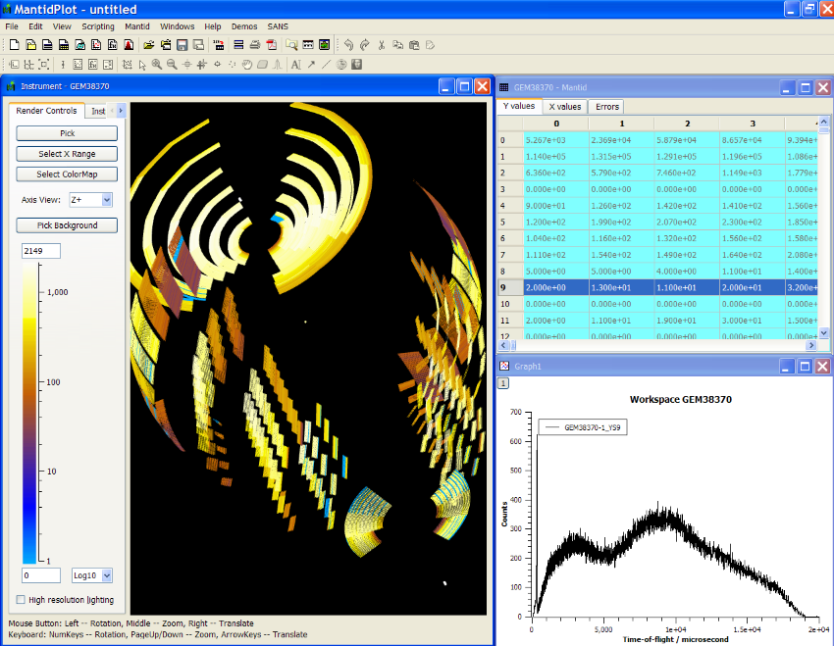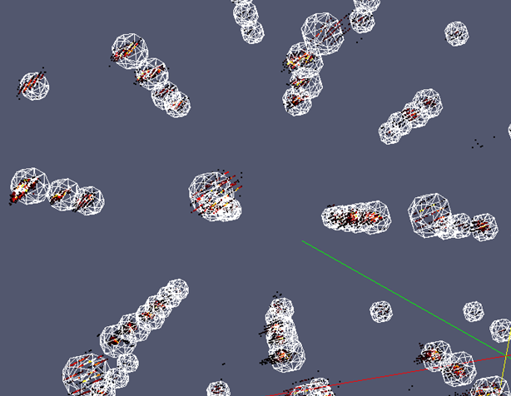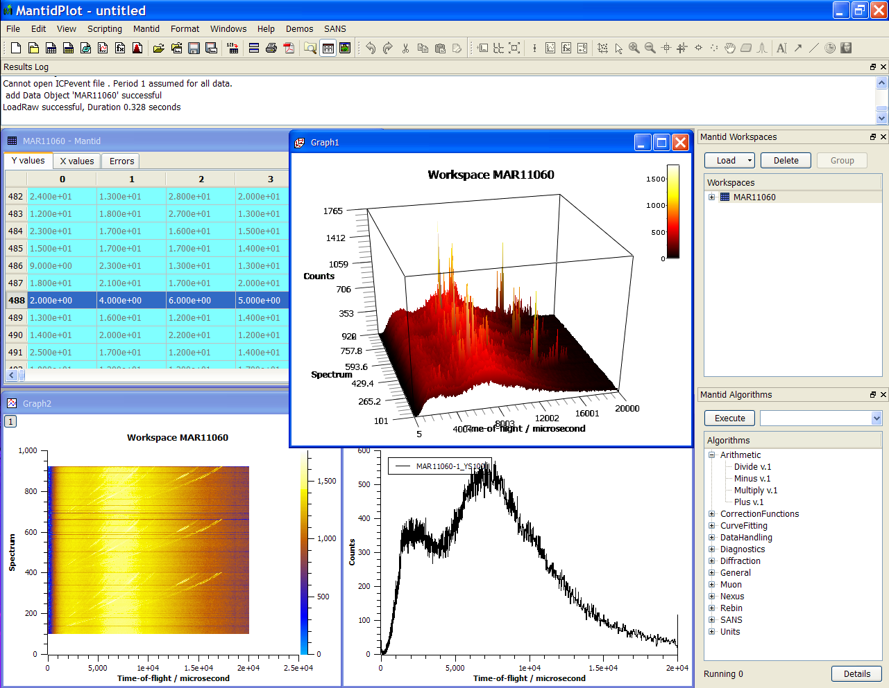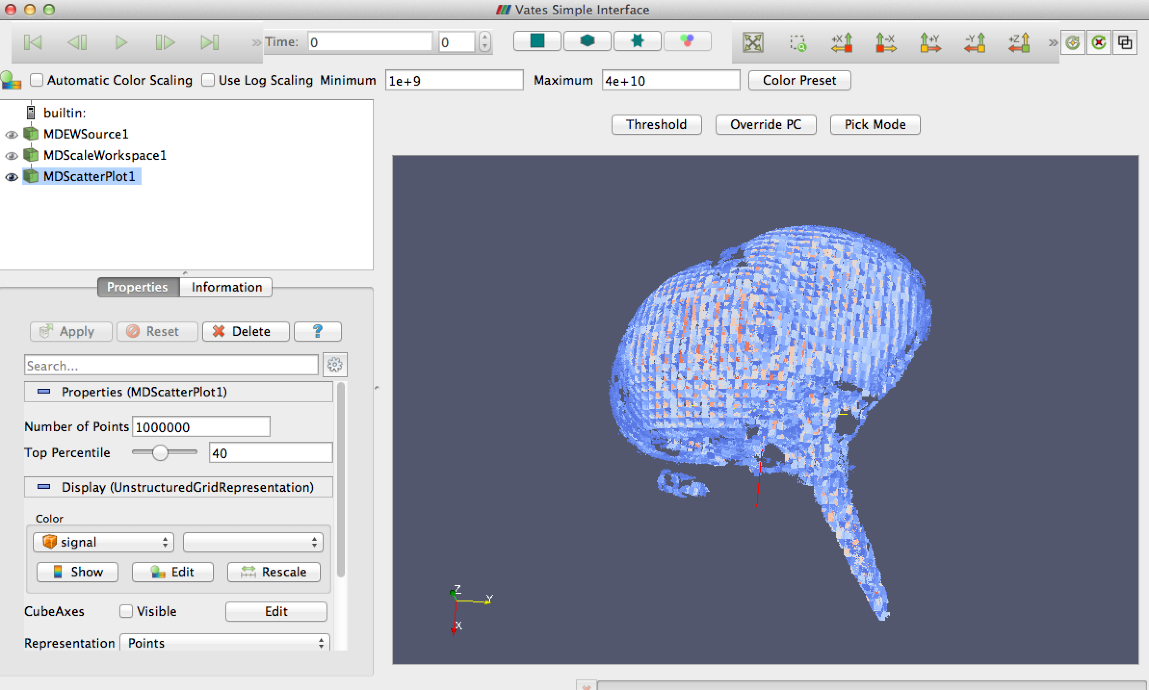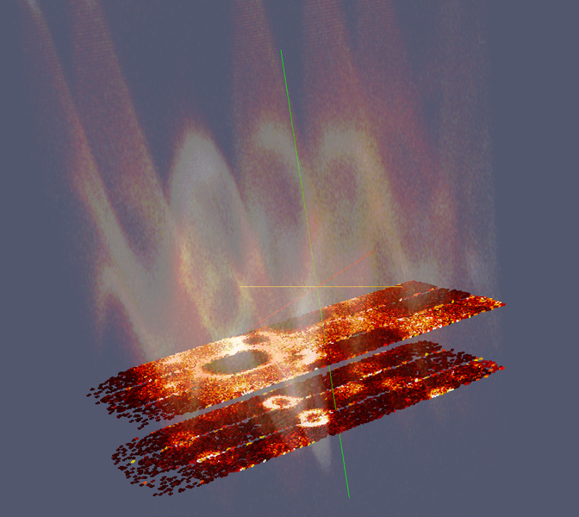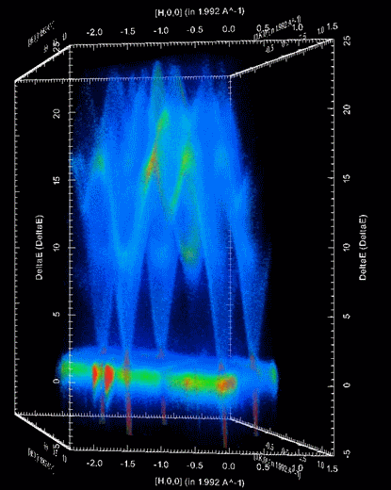

Document Control

This document is under document control. All members of the distribution list will receive updated copies whenever alterations are made. All other copies are uncontrolled.

Contributors

|  |  |  |
| --- | --- | --- |
| Name | Role | Company |
| Nicholas Draper | Author | Tessella |

Document Approval

|  |  |  |
| --- | --- | --- |
| Name | Role | Company |
|  |  |  |

Distribution

|  |  |  |
| --- | --- | --- |
| Name | Role | Company |
| Project Management Board Members | Recipient | Mantid Partnership |
| Mantid Project Repository | Filing | Mantid Partnership |

Revision History

|  |  |  |  |
| --- | --- | --- | --- |
| Author | Issue | Date | Description |
| Nicholas Draper | V1.R1.M0 | 19-Jan-2019 | 1st version written |

References

|  |  |  |  |
| --- | --- | --- | --- |
| Document | Ref | Date | Details and Version |
| Cross Facility Technique support results | [CFT] | 14-Jan-2019 | <https://github.com/mantidproject/documents/blob/master/Project-Management/PMB/Mantid%20Cross%20Facility%20Technique%20support.xlsx> |

Table of Contents

1 Introduction 3

1.1 Purpose of this Document 3

1.2 Scope of this Document 3

2 Purpose of the review 3

2.1 Approach 3

3 Summary 4

4 Reasons for Differences 4

5 Findings by technique 4

5.1 Powder Diffraction, Engineering and Total scattering TOF 4

5.2 Powder Diffraction Constant Wavelength 5

5.3 SANS 6

5.4 Reflectometry 6

5.5 Direct Inelastic 7

5.6 Indirect Inelastic 7

5.7 Muon 8

# Introduction

## Purpose of this Document

This report describes the results of the review of the approaches for supporting the various techniques across all of the contributing facilities, highlighting were approaches and code is shared and where approaches differ and the reasons behind those differences.

## Scope of this Document

The scope of this document is limited to the Mantid project, and the collaborating facilities within the project, for the initial review, wider users of Mantid such as ANSTO, the CSNS and HZB were not included.

# Purpose of the review

At the September 2018 PMB meeting a review of the approaches that have been taken at differing facilities for all of the techniques Mantid supports was requested, with a particular view to understand where approaches are similar or differ both within facilities and between them. This was intended both to understand and document the reasons for those differences and identify opportunities to share approaches and code more widely.

## Approach

The review was conducted through the use of shared spreadsheets for gathering initial information followed by a series of meetings of the team members involved for discussions and delving into the details and differences.

# Summary

Mantid was designed to split out workflows into small reusable Algorithms that could be shared across instruments, techniques and facilities. At that level we have very good reuse of algorithms both within and across facilities. There are a few notable exceptions, but they are in the minority.

We have focussed on reviewing all of the user interfaces and workflows in use at all of the contributing facilities for the Mantid project. There are some situations where we have good shared use within each facility, such as in powder diffraction and direct inelastic spectroscopy at all facilities. However we have also identified areas that differ even within a facility either for reasons that were due to pressures or requirements during development, or for more fundamental reasons that remain true even when considered without those restrictions.

Across the different facilities there is much less sharing of workflows or user interfaces. This has primarily been driven by the need for reduction within Mantid to mirror the workflow and results of previous software implementations that have been present at ISIS, SNS, HFIR and the ILL. There are a few examples of cross facility sharing such as the Data reduction interface for ISIS and the ILL, but this is a rarity.

We have explained the reasons for differences and opportunities for greater cross instrument and facility support within the findings per technique below.

# Reasons for Differences

Within the findings per technique section blow some specific reasons for differences have been documented. There were some repeated and generally reasons that repeated across most of the developments across Mantid.

* For three of the contributing facilities Mantid has replaced previous existing data reduction software solutions. Almost universally in each case one of the prime requirements has been that Mantid should follow the data reduction workflow that has been designed into the previous solution, and produce results that are very similar if not exact to the previous solution.
* Adding support for a new instrument into Mantid is usually done under significant time pressure. While developers are made aware of all previous workflows, and helped to understand them, it is common that the developed workflows can appear complex compared to the simple support they are under pressure to deliver quickly. This leads the developers to take the simplified heart of the existing workflows and build a quick solution from that. However this does lead to the creation of another similar, but different workflow.
* Instruments that are newly supported or those that are more flexible in the experiments they support may need to change their workflow or interface more often. With a separate implementation that is shared by less people there is less risk that a change made for them will risk unforeseen impact on others.
* The final common reason for differences is due to significant differences in the instrument or the structure of the data provided to Mantid leading to differences in the workflow.

# Findings by technique

The full document captured during the review is here:

<https://github.com/mantidproject/documents/blob/master/Project-Management/PMB/Mantid%20Cross%20Facility%20Technique%20support.xlsx>

The following sections will provide a brief summary highlighting the similarities and differences.

## Powder Diffraction, Engineering and Total scattering TOF

### GUI

#### Powder diffraction & Total Scattering

Most of the techniques at ISIS do not have a user interface for powder diffraction and are happy to work with simple script command of their workflow. The direction of development for ISIS will to be towards autoreduction rather than GUI development for powder diffraction. They do make use of the plotting and other tools within Mantidplot for visualising their data.

ORNL has a powder diffraction interface “Diffraction->Powder Diffraction reduction” which is a relatively thin wrapper over the SNSPowderDiffractionReduction workflow, and ADDIE for PDF reduction and total scattering.

#### Engineering

ISIS and the SNS have separate interfaces that have been developed separately. ISIS has an Engineering interface that was developed following the desires of the Engin-X instrument scientists, it is close to being ready for adoption, but is not in active use at present. This interface supports data reduction, single peak fitting and rietveld refinement (using GSAS2).

ORNL has developed PyVDrive for Vulcan that supports data reduction and peak fitting. They have also developed PyRS that supports HB2B and allows for stress strain and texture analysis, but the calculations for these are specific for constant wavelength instruments at present.

### Workflow

#### Powder diffraction

The overall structure of the workflow between ISIS and the SNS is similar, but there are several differences both between and within the facilities.

There are currently two different workflows for powder diffraction at ISIS, most instruments use the isis_power routines, with the exception of WISH which uses scripts that were originally written by Pascal and are maintained by the instrument scientists. The WISH routines are fundamentally similar, but normalise to monitor instead of current due to a complex background, and can process a run one panel at a time due to the data size.

At ORNL they have some high level workflow algorithms that are more specific for particular instruments, such as SNAPReduce, but they all use a common workflow AlignAndFocusPowder under the surface.

#### Engineering

The workflow for Engin-X reduction and calibration is captured in the various Engg* workflow algorithms. These have been created to emulate the scripts they previously had, and therefore differ somewhat from the existing Powder diffraction scripts, particularly around calibration. Some of the high level of the workflow was previously embedded in the GUI code, this is now being extracted into a script for use in autoreduction. Once autoreduction is widely adopted we will consider removing this functionality from the GUI.

PyVDrive contains much of the reduction workflow for Vulcan within the UI code.

#### Total scattering

Both ISIS and SNS are currently following the same approach based on the script originally from Marshall McDonnell.

### Algorithms

There is a good use of common algorithms across the workflows, primarily:

* Powder Focussing: AlignDetectors and DiffractionFocussing
* Several Absorption and multiple scattering corrections
* Calibration algorithms: Crosscorrelate, GetDetectorOffset(MultiPeaks), ApplyCalibration
* Diffcal and Cal File Loading
* File saving to GSAS and XYE formats

### Opportunities

#### Engineering

Both ISIS and ORNL have partial solutions and would like some of the functionality that the other has developed. There is a clear opportunity here and we have been actively investigating the best way forward.

#### Powder Diffraction workflow

* ISIS could move to use AlignAndFocusPowder harmonising back end with SNS & total scattering. Estimate 2wk per instrument.
* We could also look to support WISH within the isis-powder routines, extending them to allow for processing large instruments in chunks. Estimate 4wks.

## Powder Diffraction Constant Wavelength

### GUI

None of the solutions for constant wavelength have developed a user interface yet.

### Workflow

There is more individuality with every instrument having a bespoke workflow.

* HB2A uses HB2AReduce which was developed to use the spice format, it supports the scanning instrument and only does very simple processing.
* HB2C/WAND2 uses WANDPowderReduction that was built specifically for this constant wavelength instrument.
* D2B uses a set of workflow algorithms written specifically for the instrument because:
  1. The detector is a scanning position sensitive 2D detector
  2. With a monochromatic beam
  3. Requires Multiple files (scans) to merge
  4. Uses and in-house method for detector efficiencies using vanadium scans

### Opportunities

There are no obvious opportunities here, although further investigations or considering more significant rework might identify some.

## SANS

### GUI & Workflow

ISIS SANS has two interfaces, one that was developed many years ago and was one of Mantid’s first interfaces, and a more modern replacement that is testable and much more maintainable. The new interface is planned to enter use in the next ISIS cycle.

SANS at ORNL has an interface, there is little similarity between this interface or indeed the underlying workflow and that at ISIS. This was due to differing opinions between the relevant key instrument scientists on the reduction and correction approaches. We organised and hosted meetings to try to resolve this, but neither group was willing to change.

ILL does not yet have an interface, but does plan on developing one and is planning to use the JobTreeView central widget that is in use in both the SANS and reflectometry interfaces at ISIS. They have developed a bespoke workflow after considering that offered by ISIS and ORNL, following the approaches used in LAMP and GRASP. This minimal and simple approach is considered easier to support at the ILL.

### Opportunities

* At present William Hellier along with Mike Fitzsimmons are documenting the analysis requirements for EQ SANS. Then a new set of workflow algorithms and python will be created, those available at ISIS will be considered if the workflow overlaps significantly. Where possible common algorithms underlying the workflow will be used.
* If the future ILL interface uses the JobTreeView it will benefit from the shared invested in this central tool.

## Reflectometry

### GUI & Workflow

ISIS Reflectometry has an interface built around the common JobTreeView widget that is shared with the SANS interface. The interface is centred around the workflow algorithm used for all of the ISIS reflectometers, ReflectometryReductionOneAuto.

The Magnetism and Liquids Reflectometers both have their own external application that make use of Mantid for the reduction workflow. The workflows for each are bespoke there are slight differences in calculation and meta data handling have led to different versions of the scripts at different instruments.

ILL does not yet have an interface. They have developed a bespoke workflow to handle that their initial data is organized differently (separate direct and reflected measurements), and the instrument scientists were keen to follow the approaches from COSMOS.

### Opportunities

* Background subtraction approaches could be developed in parallel with the SNS.
* We could split up ReflectometryReductionOne and follow or harmonise with the ILL approach we would need to investigate this further.
* The ILL plans to extend their workflow to use FindReflectometryLines and SpecularReflectionPositionCorrect in the future.
* Future opportunity to harmonise the two ORNL instrument workflows now the DAE is being updated. Several corrections are likely to be able to be picked up from ISIS. Q resolution calculations from the ILL would be useful to make use of as well (if we can separate the point where it also sums in Q).

## Direct Inelastic

### GUI

No facility uses an interface for the data reduction. ORNL did develop a DGSReduction interface, but no longer use or support it. It is still in use by HZB instruments so it is has not been removed from Mantid. ORNL uses autoreduction for these instruments and that is the direction planned by ISIS as well.

mSlice for Mantid has been developed as a common interface intended for use at all facilities for slicing data.. It is in active use at ISIS and undergoing evaluation for active use at ORNL.

The ILL does not currently have an interface and is currently using the LineProfileAlgorithm to create simple 1D slice graphs of their data, but could probably use mSlice.

### Workflow

ISIS has developed a bespoke workflow as a set of python scripts. The initial code was the direct conversion of the Matlab LIBISIS to Python. The Python implementation proven to be much more flexible and convenient solution, fully satisfying the ISIS needs. This code is supported by the Excitations group.

SNS have developed the DGSReduction set of workflow algorithms and this supports all of the instruments at the SNS.

Both of the independent solutions at ISIS and the SNS have been developed to support basic data reduction for the other facility, but each has much more functionality and support for their own instruments. The basic workflow is similar, but there are significant differences in the details. Each group is happy with their workflow implementation, and while they agree that there is no reason they could not harmonise there is little interest in actually prioritising the effort required.

The ILL after investigation of the approaches by ISIS and the SNS decided to build a simpler much less complicated workflow that supports much less flexibility but is much easier for their small team to support and maintain.

### Opportunities

None at present without prioritisation of harmonisation by the instrument scientists.

## Indirect Inelastic

### GUI

ISIS and the ILL share a common user interface for data reduction, with Mantid providing the correct ILL or ISIS data reduction tabs depending on the facility you have selected. The SNS primarily uses autoreduction, but also has a separate Data Reduction GUI, but it shares the same menu command in Mantid to launch it as the others in Mantid, just launching the SNS Indirect Data Reduction GUI if the facility is set to SNS, These approaches support BASIS, VISION is supported by custom scripts and has now GUI.

Beyond data reduction ISIS has a collection of other GUI’s that support further corrections, and aspects of data analysis and simulations. These are called:

* Bayes
* Data Corrections
* Simulations

These could be used by the ILL, but they currently have some assumptions about file naming that would need to be made more flexible.

Diffraction on indirect instruments is supported by a separate interface at ISIS.

### Workflow

While some of the GUI’s are shared, the underlying workflows are different for each facility.

For indirect Energy transfer data reduction compared to ISIS the differences are primarily due to instrument differences:

* BASIS uses PSD tubes which warp significantly in reciprocal space.
* IN16B at the ILL:
  + Doppler drive instead of choppers
  + Mirror sense (acceleration and deceleration phases separately)
  + Elastic and Inelastic scans
  + Outputs Multiple files (O(1000))

For diffraction in indirect instruments at present this is supported by separate workflows at ISIS and the SNS, and the workflow is separate from the isis_powder routines used for the other instruments.

### Opportunities

* The Simulations, Data Reductions and Bayes interfaces could be used at the ILL once the file naming assumptions are made more flexible, and they have been fully evaluated there.
* It is a low priority requirement to move indirect diffraction support into isis_powder, and deprecate the isis->indirect->diffraction GUI.

## Muon

### GUI

ISIS is the only facility in the collaboration that supports muon spectroscopy instruments. They have a collection of interrelated interfaces to analyse their data: Muon Analysis, Elemental Analysis, ALC and Frequency domain analysis.

### Workflow

The workflow for processing the data has recently been extracted from the interface code and put into a workflow algorithm MuonProcess.

### Opportunities

* Some of the GUI widgets developed as part of the Muon GUI’s may be useful for other interfaces
* A new multi axes plot window built from the Mantid MatPlotLib routines will likely be included as a general tool in a future Mantid Workbench release.